Elevator

Many developments have occurred in recent years in industries such as industry, computing, and software. They have made tremendous advancements in a variety of fields. You summon a metal box by pressing the switch or button, which safely transports you from one floor to the next. In reality, if a building has more than four to five floors, an elevator is required. An elevator provides ease and convenience for the majority of people, as well as making life easier for physically challenged people. This article explains what an elevator is, how it works, and the different types of elevators.

An elevator is an electric lift that transports products and people vertically between floors in buildings utilizing bins or silos. As is customary, these are powered by electrical motors that also drive counterweight system cables for drive transactions like a hoist, or pump hydraulic fluid to raise a cylindrical piston like a jack. These are employed in a variety of fields, including agriculture, manufacturing, and so on. Elevators are categorized into many sorts based on our needs. Elevators are widely employed in modern multistory buildings, particularly where wheelchair ramps would be impractical.

Types of Elevators

1. **Hydraulic elevator**
2. **Pneumatic elevator**
3. Traction elevator
4. Capsule elevator
5. Building elevator
6. Passenger elevator
7. Freight elevator
8. Residential elevator

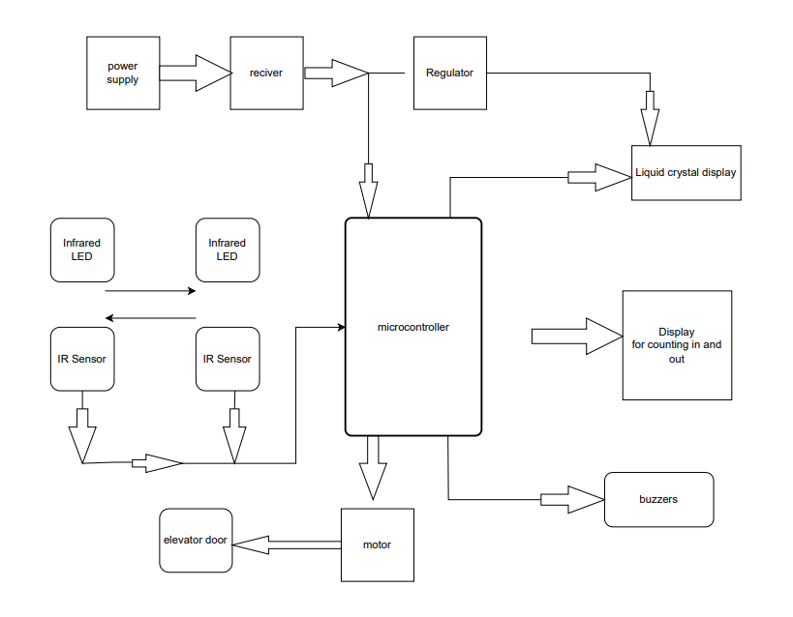

Elevator circuit diagram

An elevator or lift works on the same concept as a pulley system. The water is drawn from the well using a pulley system. A bucket, a rope, and a wheel can all be used in this pulley system. A bucket is attached to a rope that runs the length of a wheel. This might make drawing water from the well a breeze. Similarly, modern elevators operate on the same principle. However, the fundamental difference between the two is that pulley systems are manually operated, whereas elevators use sophisticated mechanics to handle the elevator's load.

An elevator is essentially a metal box of various designs that is attached to an extremely strong metal rope. In the engine room, the robust metal rope runs through a sheave on the elevator. A sheave acts as a wheel in a pulley system, tightly grasping the metal rope. A motor can be used to control this arrangement. The motor can be triggered when the elevator goes up and down or stops when the switch is switched on.

The elevator can be built using a variety of elevator components or parts, which include the speed control system, electric motor, rails, cabin, shaft, manual and automatic doors, drive unit, buffers, and safety device, among others.